**Vivekanand Education Society’s Institute of Technology**

**Department of AI Engineering**



**Subject: Social Media Analytics**

**Class: D16ad**

| **Roll No: 30** | **Name: Suhanee Kandalkar** |
| --- | --- |
| **Practical No: 5** | **Title:**  Content based Social Media Analytics |
| **DOP:** | **DOS:** |
| **Grades:** | **LOs Mapped:** |
| **Signature:** |  |

**Title:** Content based Social Media Analytics

**Aim:**  To perform Content based Social Media Analytics for local Businesses.

1. Scrape Google reviews for Local businesses.
2. Perform Topic Modeling and Sentiment Analysis on scaped reviews.

**Theory:   
 Content-Based Social Media Analytics for Local Businesses**

1. Text Analytics Layer of Social Media Analytics

The **Text Analytics Layer** is a crucial component of Social Media Analytics that helps in extracting and processing textual data from online sources. It consists of several stages:

### **1.1 Data Collection**

.

### **1.2 Data Preprocessing**

### **1.3 Feature Extraction**

### **1.4 Text Analytics Techniques**

## **2. Topic Modeling and Sentiment Analysis**

### **2.1 Topic Modeling**

#### **2.1.1 Common Topic Modeling Methods**

* **Latent Dirichlet Allocation (LDA):**
* **Non-Negative Matrix Factorization (NMF):**

#### **2.1.2 Application in Google Reviews**

* A local coffee shop scrapes its Google reviews and applies **LDA Topic Modeling**.

**OUTPUT:**

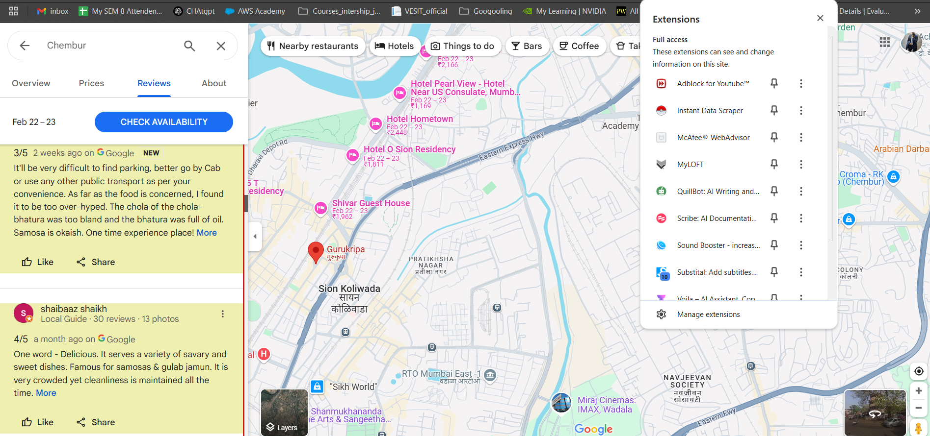

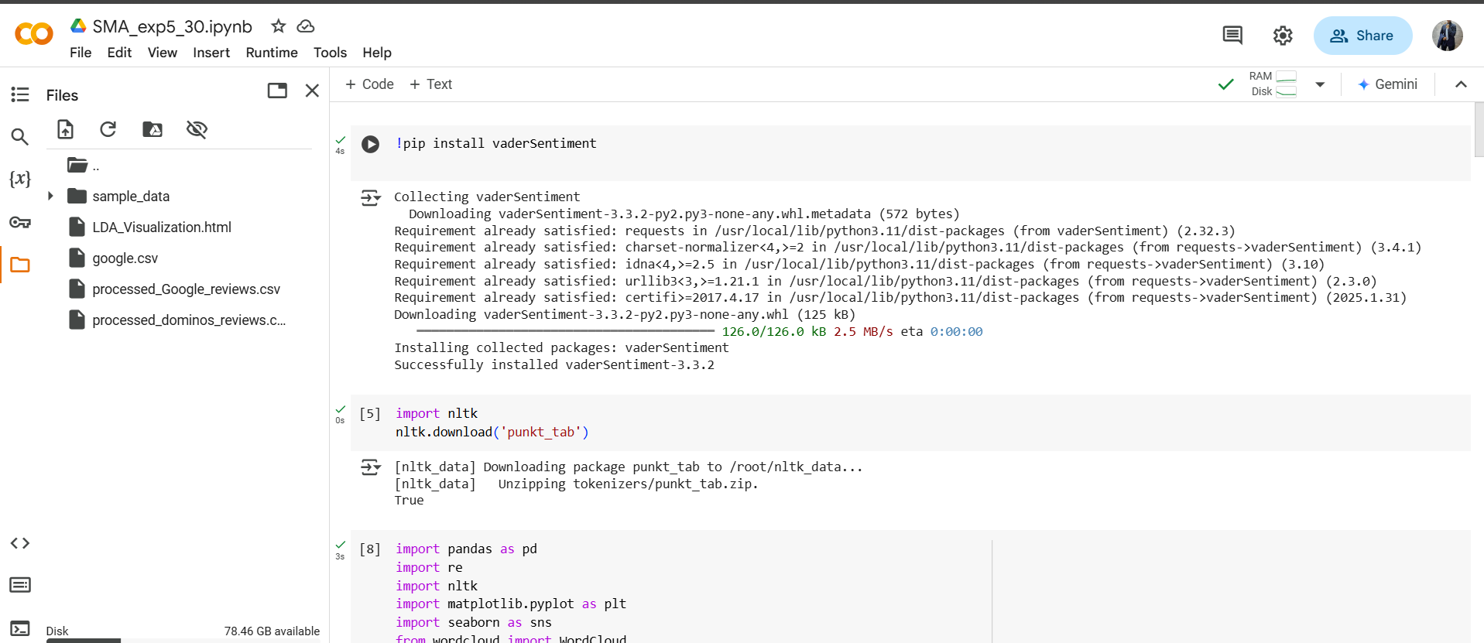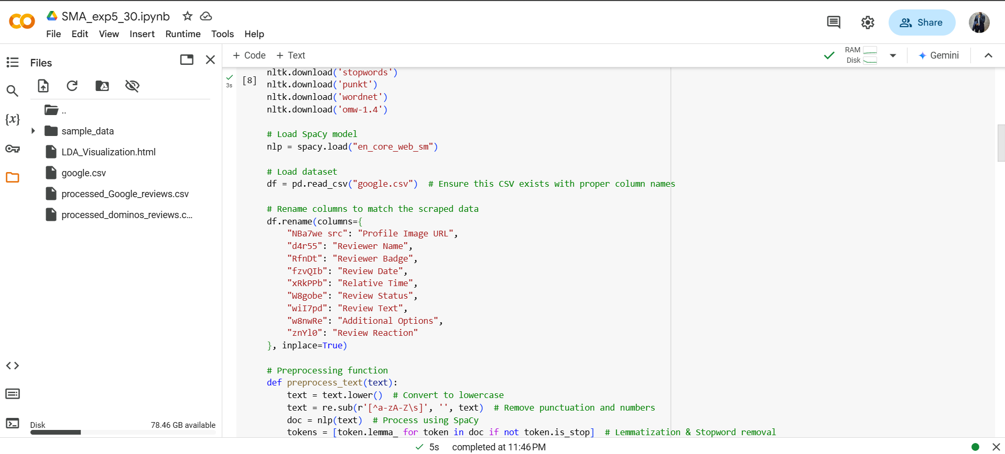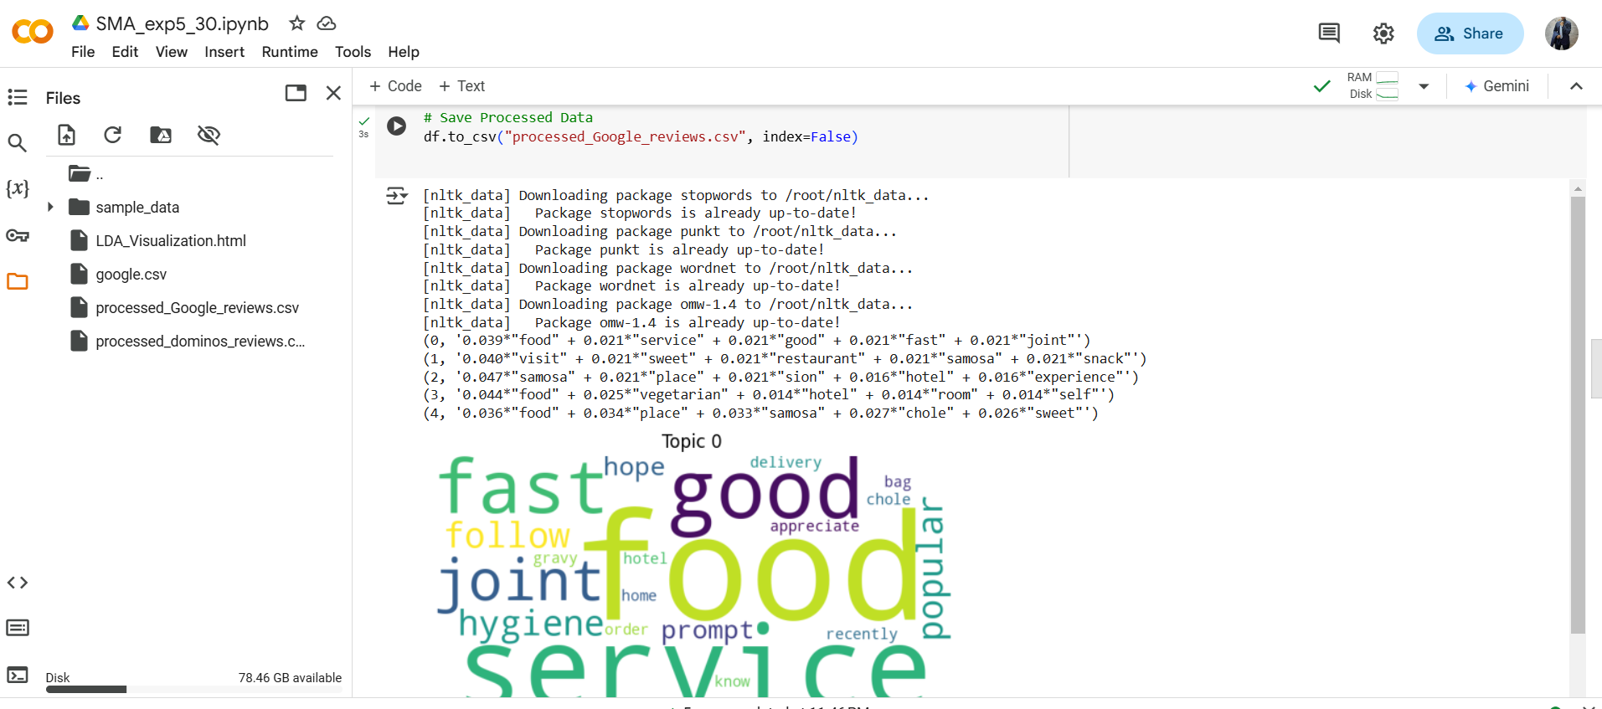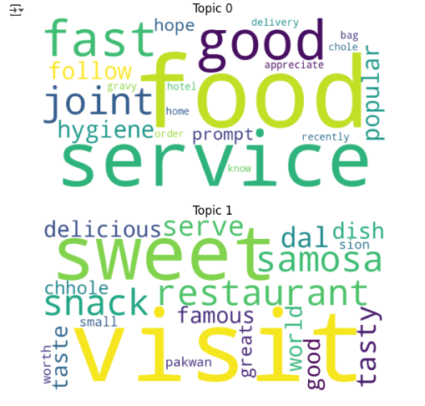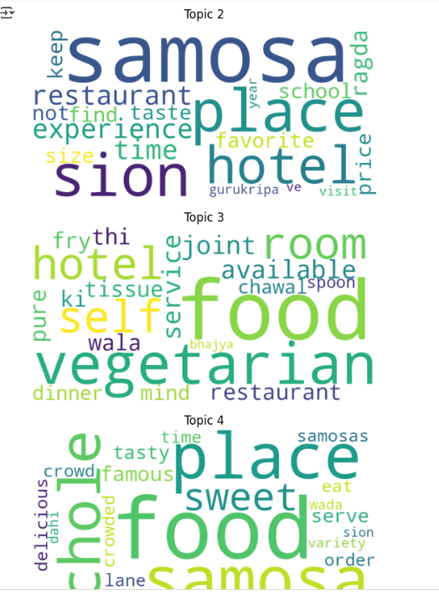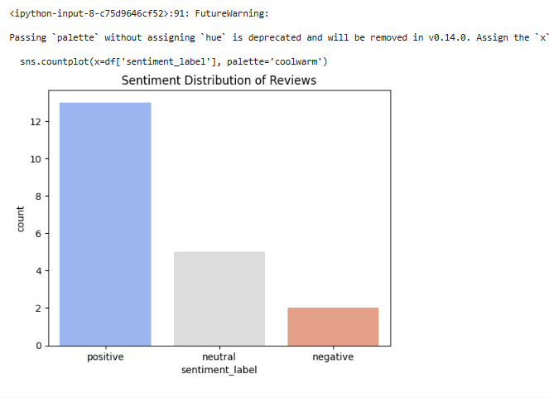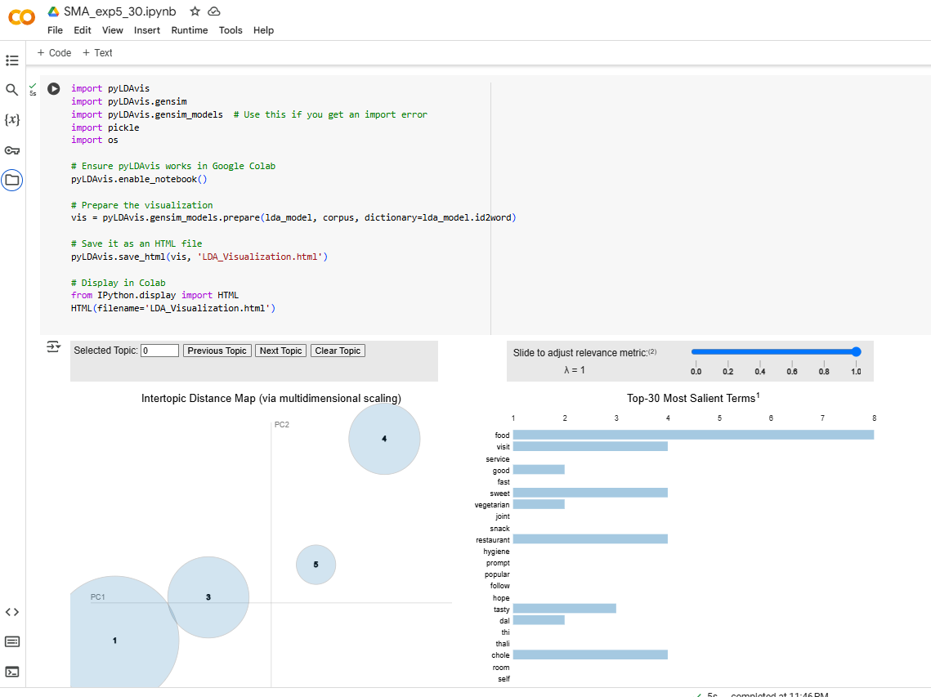

**Conclusion:**

By performing Content-Based Social Media Analytics, businesses can gain data-driven insights into customer experiences. Scraping Google reviews, applying Topic Modeling to uncover key themes, and conducting Sentiment Analysis help businesses make informed decisions to improve customer satisfaction and brand reputation.